ISTANBUL TECHNICAL UNIVERSITY
COMPUTER ENGINERING DEPARTMENT

BLG 546E MACHINE LEARNING
CRN: 23438
Instructor: Tolga Ovatman

Report of Homework #2
April 8, 2018

Tuğrul Yatağan
504161551

Development, Build and Test Environment
Ubuntu 16.04.4 LTS Linux kernel 4.4.0-116-generic is used for build and test environment. Test system has 6 GB of RAM and 8 core i7-3632QM 2.20 GHz CPU. Oracla Java 8 is used for Java virtual machine. Following commands is used for installing Java virtual machine and IntelliJ IDEA:
sudo add-apt-repository ppa:webupd8team/java
sudo apt install oracle-java8-installer
sudo snap install intellij-idea-community -classic

Example screen shot of development environment:
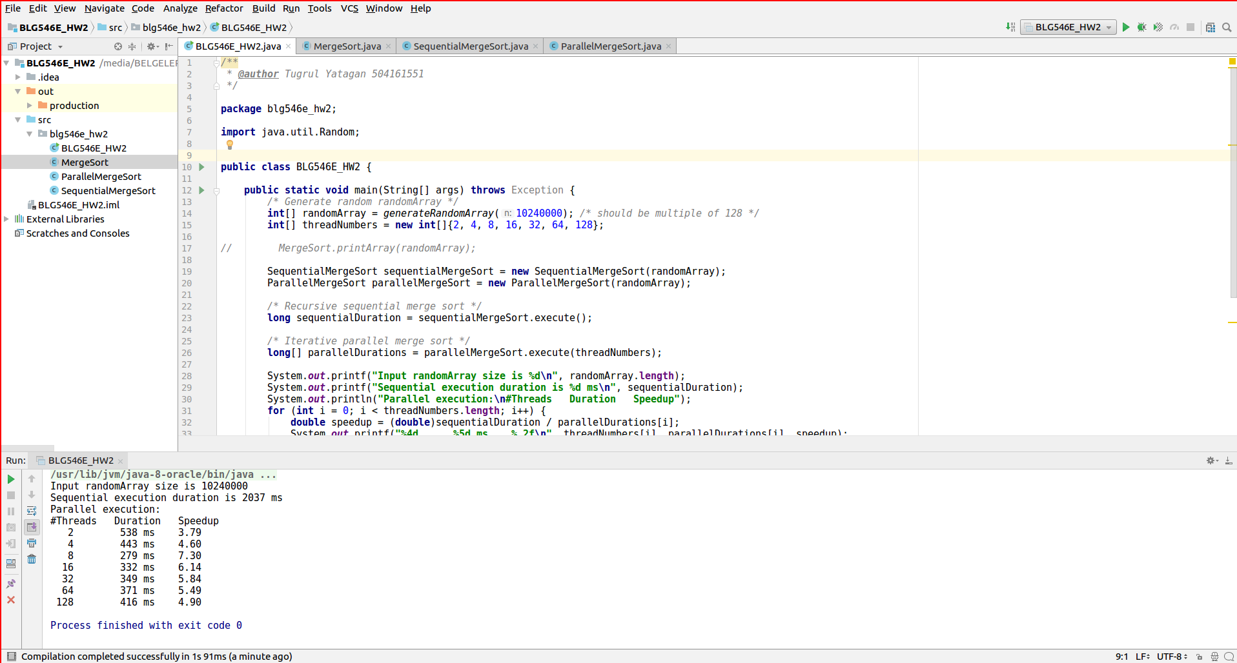
Example output:
Application is run with different array size parameters; 1 million, 10 million and 100 million.
n=100M
Input randomArray size is 102400000
Sequential execution duration is 20519 ms
Parallel execution:
#Threads Duration Speedup
2 5178 ms 3.96
4 4349 ms 4.72
8 2885 ms 7.11
16 3214 ms 6.38
32 3416 ms 6.01
64 3510 ms 5.85
128 3810 ms 5.39

n=10M
Input randomArray size is 10240000
Sequential execution duration is 2052 ms
Parallel execution:
#Threads Duration Speedup
2 548 ms 3.74
4 417 ms 4.92
8 276 ms 7.43
16 356 ms 5.76
32 353 ms 5.81
64 363 ms 5.65
128 409 ms 5.02

n=1M
Input randomArray size is 1024000
Sequential execution duration is 230 ms
Parallel execution:
#Threads Duration Speedup
2 136 ms 1.69
4 50 ms 4.60
8 40 ms 5.75
16 40 ms 5.75
32 43 ms 5.35
64 56 ms 4.11
128 83 ms 2.77

Test Results
Execution time for sequential and parallel method are put in a chart. Also speedup factors for all methods are calculated in respect to sequential method.
Following tables shows that concurrency is good until number of threads exceeds number of physical CPU cores. Maximum speedup on 8 core machine is 7.33x not 8x. Also speedup curve shape fits Amdahl’s Law.
Sequential execution method uses recursive merge sort however parallel execution uses iteration since there is no way to use merge sort recursion between different threads. Recursive function calls brings extra overhead to sorting which results slower execution time. This might be the reason why parallel execution gives much better execution time.

Best execution time is 2885 ms with 8 threads

Best execution time is 276 ms with 8 threads

Best execution time is 40 ms with 8 threads

Best speedup factor is 7.33x with 8 threads

